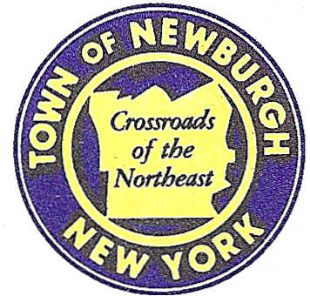

TOWN OF NEWBURGH
_______Crossroads of the Northeast __________________________

21 HUDSON VALLEY PROFESSIONAL PLAZA
NEWBURGH, NEW YORK 12550

PLANNING BOARD
JOHN P. EWASUTYN, CHAIRMAN
TELEPHONE 845-564-7804
FAX 845-564-7802
E-MAIL: planningboard@townofnewburgh.org

PLANNING BOARD AGENDA

July 7th, 2022
7:00 PM

*PLEASE NOTE: The Planning Board Meeting will start at 7:00 P.M. and all Applicants/Representatives
are to be present at that time. The Meeting will be held in the Meeting Room of Town Hall,
located at 1496 Route 300, Newburgh NY.*

This will be an in-person meeting at Town Hall

Online meeting materials: http://www.townofnewburgh.org/cn/meetings/

- Longview Farms (6-39) FINAL APPROVAL
Barbara Drive 26 LOT SUBDIVISION/6 LOT LINE CHANGES
Section 20, Block 1, Lot 1
Section 20, Block 1, Lot 3.35
Zone: AR
Rep: T.M. DePuy Engineering & Land Surveying, P.C.
2656 Route 302
Middletown, NY 10941

- 14 Marino Drive/Afonso (22-11) TWO LOT SUBDIVISION
14 Marino Drive
Section 2, Block 1, Lot 16 & 23.2
Zone: RR
Rep: Doce Associates
41 Mead Alley
Montgomery, NY 12549

- Hudson Asset (22-10) TWO LOT SUBDIVISION
Union Avenue TWO FAMILY/ARB
Section 34, Block 1, Lot 25.15
Zone: R-2
Rep: Engineering & Surveying Properties, P.C.
Clinton St.
Montgomery, NY 12549

- Overlook Farms (19-23) PUBLIC HEARING 5417 Route 9W SITE PLAN
Section 9, Block 1, Lot 10, 11, 12, 56.21 & 56.22
Zone: R-3/B
Rep: JMC Pllc.,
120 Bedford Road
Armonk, NY 10504

- Monarch Woods Senior Housing (19-28) PUBLIC HEARING
Monarch Drive MULTI-FAMILY SENIOR HOUSING/
Section 103, Block 7, Lot 18 SITE PLAN
Section 47, Block 1, Lot 46
Zone: R
Rep: Engineering & Surveying Properties, PC
71 Clinton Street
Montgomery, NY 12549

PLANNING BOARD BUSINESS –July 7th, 2022
WORK SESSION—5:30 PM Start time

